School District 43 Parents Advisory Council Jan. 29, 2014

**Toastmasters Youth Leadership Program**

DPAC 43 would like to support the development of leadership skills in the student population of School District 43. The Toastmasters Youth Leadership Program (YLP) provides an excellent opportunity to build our student leadership. The following summary outlines what the YLP is, how it can be initiated within your school, and some resources available to set up the program.

**What is the Youth Leadership Program?**

This Toastmasters International program is designed to teach leadership skills to school aged children. It consists of 8 sessions, held just after school, or before dinner, or early evening. For a new YLP Coordinator, class size can be limited to 12 students, with 1-hour sessions. Participant selection could give preference to the highest grade in the school since those students will not have the same opportunity the following year. Preference could also be given to students already in a leadership role. An aptitude screening questionnaire might be helpful.

Our school curriculum already provides some initial training in public speaking. The YLP supports and builds on that, providing training in:

* 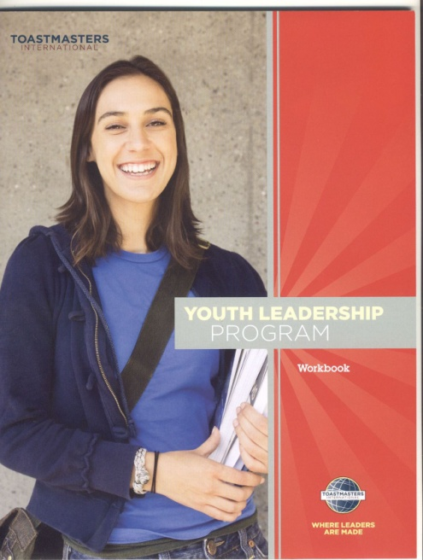Chairmanship
* Executive roles
* Constructive peer evaluation
* Impromptu speaking
* Leading discussions

The YLP ensures enduring value, by

* Providing practical experience
* Building confidence
* Creating the self image of an effective leader

**Costs:**

Toastmasters International YLP is provided at no cost to participants. Students receive a 36-page workbook. Material cost is minimal, and usually covered by the local sponsoring Toastmasters club. The Toastmaster Coordinator and Assistant Coordinator roles are volunteer positions.

… / over

**Opportunity for your school:**

DPAC executive member Chuck Denison can assist your PAC to bring your school and Toastmasters resources together to initiate a Youth Leadership Program. The suggested initial steps are:

1. Take this introductory information to your PAC and school administration.
2. Through your school Newsletter, identify parents who are current or past Toastmasters members willing to present the YLP at your school. There is usually an assistant presenter who could be a Toastmaster, parent or teacher.
3. Determine choices of time, location (e.g. classroom) and starting date.
4. Return that information to Chuck Denison, who will help coordinate resources.

**Resource Worksheet**

School requesting a Toastmasters Youth Leadership Program:

__________________________________________________________________

Highest grade level: _________

School administration contact(s): _______________________________________

__________________________________________________________________

Volunteer Toastmaster YLP Coordinator(s): (If nobody has been identified yet, list as “TBD”. Toastmasters may be able to match you with a Toastmasters volunteer.) __________________________________________________________________

Volunteer Assistant Coordinator: _______________________________________

Preferred weekday and time: (Note that it is usually easier to find Coordinators for evening sessions, if that is possible in your school. There might also be fewer conflicts with other student activities.)

1st choice: ____________________ 2nd choice: ________________________

Suggested starting date: _____________________

Please forward this resource worksheet to DPAC 43 support contact:

Chuck Denison, DPAC Co-VP

Phone 604-614-9772

E-mail [chuck@dpac43.org](mailto:chuck@dpac43.org)